Nutrient | What is it made up of? | How is it stored?
Carbohydrate
Fat
Protein
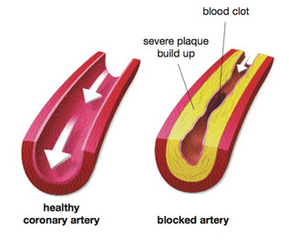
Explain how medical drugs are developed and tested
Define the two types of cancer:
Benign –

Malignant –

List the 4 types of pathogen and give an example of each one
What is active immunity?

What is passive immunity?
Define these key terms to do with disease:
Pathogen –
Vector –
Vaccination –
Antibiotics –

What is kwashiorkor?
What is the calculation for body mass index?

What is a ‘normal’ BMI?
Using the diagram, explain how arteries can become built up and cause a heart attack.
Explain how these chemicals in cigarettes affect your body:
Carbon Monoxide –
Nicotine –

List 4 factors that increase your blood pressure
What does being healthy mean?

What does being fit mean?

