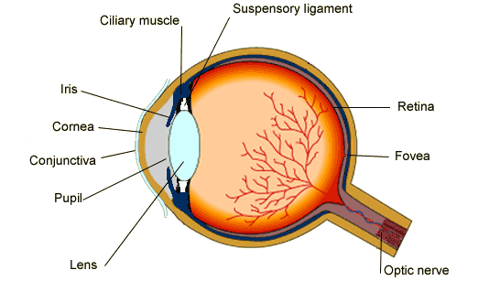

**Label the eye diagram:**

**Explain how alcohol affects the body:**

**Explain how each of these drugs affects the body:**

Depressants –

Stimulants –

Painkillers –

Performer Enhancers –

Hallucinogens –

**Explain what a synapse is and how it works:**

**What type of lens do long sighted people need to correct their vision?**

**What type of lens do short sighted people need to correct their vision?**

**Label the nerve cell diagram:** 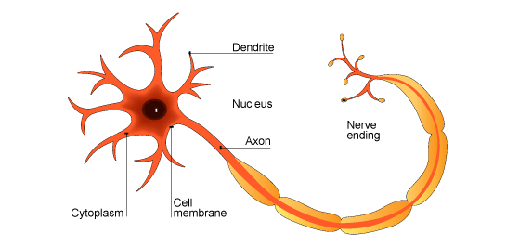

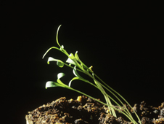

|  |  |  |
| --- | --- | --- |
| Mum Dad | E | E |
| E |  |  |
| e |  |  |

**What hormone controls blood sugar?**

**Name and describe the 2 types of diabetes:**

**What is phototropism?**

**How does a plant control phototropism?**

**How many chromosomes are there in normal body cells of humans?  
  
How many chromosomes are there in gametes of humans (sperm and egg cells)?**

**What is homeostasis?**

**Explain how the body keeps itself at a normal temperature of 37ᴼC:**