**B2 Module Summary**

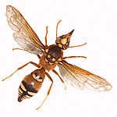

**Classifying Arthropods**

**Classifying Organisms**

**Species Definition**

**Hybrids**

**5 Kingdoms – Groups of organisms based on characteristics**

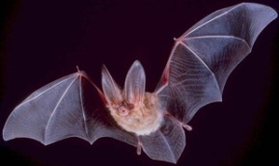

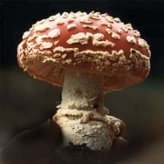

**Pyramids of numbers**

**Pyramids of biomass**

**How is energy lost at each trophic level?**

**How is dry mass measured?**

**Carbon is recycled in nature:**

Carbon is recycled in the sea:

**Nitrogen is recycled in nature**:

**Animals compete for**

**Plants compete for**

**An ecological niche is**

Predator-Prey

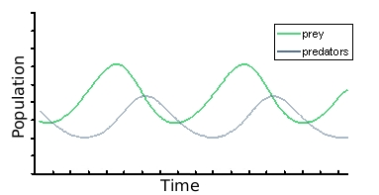

Parasites

Cleaner Species

Mutualism

**Surface Area to Volume Ratio (H)**

Camel Adaptations

Polar Bear Adaptations

Cactus Adaptations



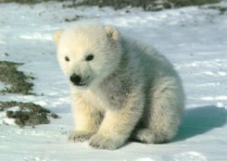

**Lamarck’s Theory of Evolution (H)**



Human Population Growth

* Exponential growth (growing at an ever-increasing rate)
* Pollution

Darwin’s Theory of Natural Selection

Examples of Natural Selection

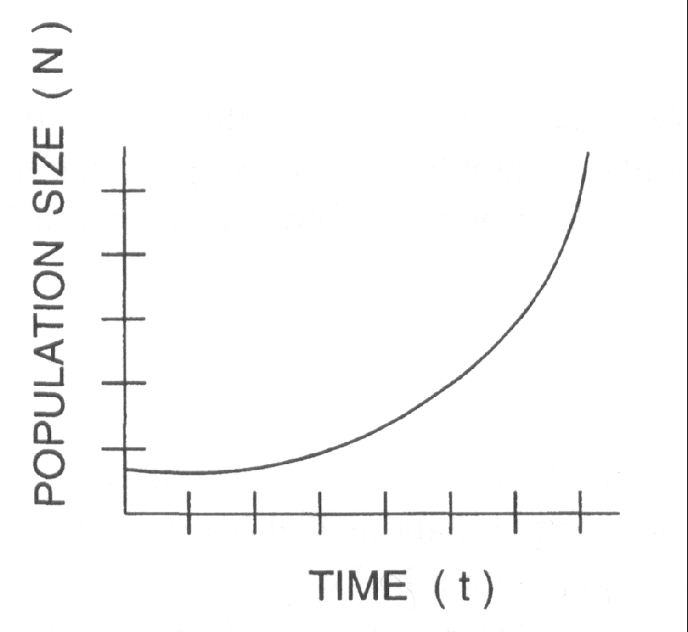

Endangered Species

Why do we protect endangered species?

The Giant Panda

Why save it? It will protect the habitat which may have plants used in medicines. The panda brings in tourism and money



Indicator Species

Whaling

For Whaling

Against Whaling

**Fishing Quotas**