Why does the liver have large numbers of mitochondria?

(HIGHER) Can ribosomes be seen by microscopes?

Where are ribosomes found in the cell?

What is the role of ribosomes?

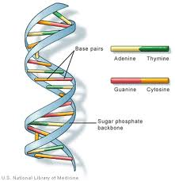

Describe the structure of DNA

(HIGHER) Explain proteins synthesis

(HIGHER) Explain how protein structure is determined by DNA base code

Define the term gene

Define the term protein:

Types of proteins:

|  |  |
| --- | --- |
| **Function** | **Example** |
| Structural | Collagen |
| Hormones | Insulin |
| Carrier molecules | Haemoglobin |
| Enzymes | ------ |

Describe how Watson and Crick used data from other scientists

(HIGHER) Explain why new scientific discoveries are not accept immediately

(HIGHER) Explain how enzyme activity is affected by pH and temperature:

Define the term enzyme

Define term gene mutation

Explain how they can occur

(HIGHER) Calculate Q10

Draw and label the lock and key model to show how enzymes work

(HIGHER) How does a mutation effect protein production?

Calculate RQ

Write the symbol equation for aerobic respiration

Write the word equation for anaerobic respiration

(HIGHER) What is ATP and how is it made?

Explain the advantages of being multicellular

1)

2)

3)

What problems do lactic acid cause?

(HIGHER) What causes lactic acid build up?

(HIGHER) How is it removed from the muscles?

(HIGHER) Explain why being multicellular requires specialised organ systems

1)

2)

3)

Compare mitosis and meiosis

|  |  |  |
| --- | --- | --- |
|  | **Mitosis** | **Meiosis** |
| **Cell type made** |  |  |
| **Number of cells made** |  |  |
| **Number of chromosomes** |  |  |
| **Number of cell divisions** |  |  |

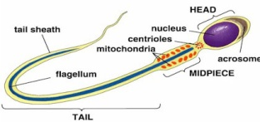

Sperm cells

|  |  |
| --- | --- |
| Structure | Function |
| Acrosome |  |
| Nucleus |  |
| Body |  |
| Tail |  |

(HIGHER) Describe process of DNA replication

(HIGHER) Explain why in meiosis the chromosome number is halved and each cell is genetically different:

(HIGHER) Write the word equation for oxygen binding to haemoglobin

Explain why fertilisation results in genetic variation:

Describe the blood vessels and explain how their structure relates to their function:

|  |  |  |
| --- | --- | --- |
| Blood Vessel | Description | (HIGHER) Structure |
| Artery |  |  |
| Vein |  |  |
| Capillary |  |  |

Explain how the structure of a red blood cell is adapted to its function:

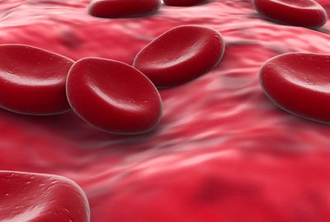

State the functions of parts of the heart:

|  |  |
| --- | --- |
| Part | Function |
| Left and right ventricle |  |
| Left and right atria |  |
| Valves |  |

Label the parts of the heart (to include L & R ventricles, L & R atria, Semilunar valves, Bicuspid valve, tricuspid valve, vena cava, aorta, pulmonary artery and pulmonary vein

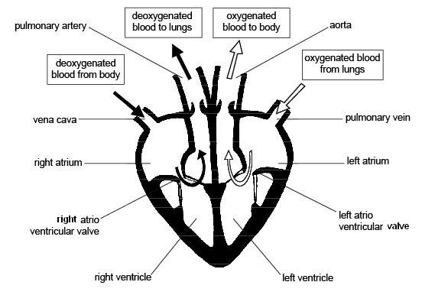

(HIGHER) Explain the advantage of the double circulatory system in mammals:

What do bacterial cells lack?

1)

2)

3)

Explain why the left ventricle has a thicker muscle wall than the right ventricle

What is the best measure of growth?

(HIGHER) How is bacterial DNA different to DNA in plant or animal cells?

(HIGHER) Types of growth

|  |  |  |
| --- | --- | --- |
|  | Advantage | Disadvantage |
| Length |  |  |
| Wet Mass |  |  |
| Dry mass |  |  |

When are the two phases of rapid growth in humans?

On a typical growth curve what type of line shows faster growth?

Define the term stem cell

Explain why plant growth is different to animal growth

1)

2)

3)

4)

(HIGHER) Explain the difference between adult and embryonic stem cells

What is the process of selective breeding?

What problem is caused by selective breeding?

Genetic engineering

* Advantage:
* Risk:
* (HIGHER) Principles:
* Examples

Dolly the sheep: outline how she was cloned:

1)

2)

3)

4)

5)

Give examples of uses of cloning

1)

2)

3)

Commercial use of cloned plants

|  |  |
| --- | --- |
| Advantage | Disadvantage |
|  |  |
|  |  |

(HIGHER) Describe plant cloning by tissue culture:

1)

2)

3)

4)

Plants retain ability to differentiate so are easier to clone, animals lose this ability at an early age.