B4 Revision Sheet
Equation for calculating population size | Assumptions that need to be made when using capture-recapture data
Define Ecosystem | Define habitat
Define community | Define population
Define transect line | Draw a kite diagram
Define zonation | Compare biodiversity of natural and artificial ecosystems

Balanced symbol equation for photosynthesis | Describe the development of the understanding of photosynthesis
Describe the two stages of photosynthesis | Describe uses of glucose in plants
Explain why insoluble starch is used for storage | Explain effect of limiting factors on photosynthesis
Explain why plants take in carbon dioxide and give out oxygen in the day | Explain why plants give out carbon dioxide and take in oxygen at night

Label the parts of the leaf  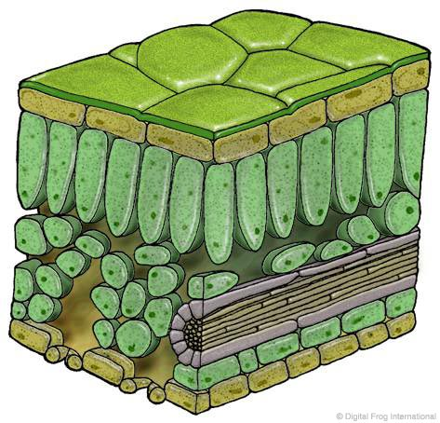 | State the function of each part  - Epidermis  - Palisade Layer  - Spongy Mesophyll

Define diffusion | Explain how to increase the rate of diffusion
Define osmosis | Define partially permeable
Define flaccid | Define plasmolysed
Define turgid | Define lysis
Define crenation | Explain how leaves are adapted to increase the rate of diffusion of carbon dioxide and oxygen

Draw the arrangement of xylem and phloem in the root | Draw the arrangement of xylem and phloem in the stem
Draw the arrangement of xylem and phloem in the leaf | Describe structure and function of the xylem
Describe structure and function of the phloem | Define transpiration
Describe the effect on transpiration of  - Increase in light intensity  - Increase in temperature  - Increase in wind  - Decrease in humidity | Explain how the structure of the leaf helps to reduce water loss
State uses of water

Describe why farmers need to use fertiliser | State uses of nitrate
State uses of phosphate | State uses of potassium
State uses of magnesium | Describe what plants deficient in magnesium look like
Describe what plants deficient in nitrate look like | Describe what plants deficient in phoshate look like
Describe what plants deficient in potassium look like

State the 3 factors that are needed for decay | Explain why microbes need oxygen and water for decay
Define detritivore | Define saprophyte
State 3 examples of detritivores | State 2 examples of saprophytes
State methods of food preservation | Define extracellular digestion

Explain the disadvantages of using pesticides | Define hydroponics  Give examples of uses of hydroponics
Explain the advantages and disadvantages of hydroponics | Explain how intensive farming improves the efficiency of energy transfer
Describe organic farming techniques | Explain the advantages and disadvantages of organic farming
Explain the advantages of biological control | Explain the disadvantages of biological control

