**Explain why fossil fuels are finite resources and are non-renewable**

**1)**

**2)**

**What problems are associated with the finite nature of crude oil**

**1)**

**2)**

**3)**

**Describe how fractional distillation separates crude oil into fractions**

**1)**

**2)**

**3)**

**4)**

**5)**

**6)**

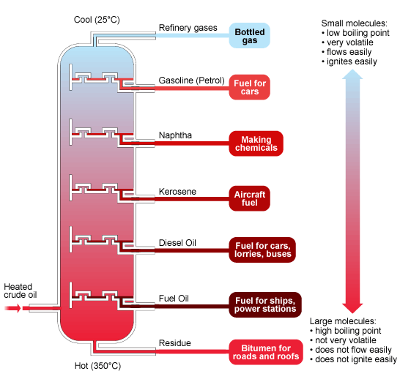

**Why can crude oil be separated by fractional distillation? (HIGHER)**

**What are the potential environmental problems involved in the transportation of crude oil?**

**1)**

**2)**

**During boiling intermolecular forces between molecules break but covalent molecules within the molecule do not (HIGHER)**

**Why is the amount of fossil fuels being burnt increasing? (HIGHER)**

**What is cracking?**

**Write the word equations for:**

**Complete combustion:**

**Incomplete combustion:**

**If you combust a hydrocarbon in a plentiful supply of air what 2 products are made?**

**Write the symbol equations for: (HIGHER)**

**Complete combustion:**

**Incomplete combustion:**

**What are the advantages of complete combustion over incomplete combustion?**

**Draw the carbon cycle label photosynthesis, respiration and combustion:**

**What is the % composition of clean air?**

**Describe how the present day atmosphere evolved**

**Describe one theory for how the present day atmosphere evolved over millions of years (HIGHER):**

**Write the word equation for the reaction that happens inside a catalytic converter:**

**Write the symbol equation for the reaction that happens inside a catalytic converter (HIGHER):**

**Define the term hydrocarbon**

**Define the term alkane**

**Define the term alkene**

**Define the term addition polymerisation**

**Define the term saturated compound (HIGHER):**

**Define the term unsaturated compound (HIGHER):**

**Bromine can be used to test for an alkene:**

**Starting colour of bromine water:**

**Positive test result:**

**This type of reaction is (HIGHER):**

**Draw the display formula for a polymer:**

**Relate the properties of plastics to simple models of their structure (HIGHER):**

**1) Plastics that have _________ intermolecular forces between _____________ molecules have __________ melting points and can be easily ________________.**

**2) Plastics that have _____________ forces between polymer molecules have ____________ melting points and can not be stretched, they are ______________.**

**Compare the properties of nylon and gore-tex:**

|  |  |
| --- | --- |
| **Nylon** | **Gore-tex** |
|  |  |

**Why is gore-tex waterproof yet breathable (HIGHER)?**

**Explain why chemists are trying to make polymers that are biodegradable or dissolve?**

**Explain why potato is easier to digest when cooked (HIGHER):**

**1)**

**2)**

**What happens to protein molecules in meat and egg when they are cooked?**

**Write the word equation for the decomposition of sodium hydrogen carbonate:**

**Write the balanced symbol equation for this reaction:**

**Define the term emulsifier**

**Explain why an emulsifier helps to keep oil and water from separating (HIGHER):**

**Explain why perfume needs certain properties:**

|  |  |
| --- | --- |
| **Property** | **Reason** |
| Easily evaporates |  |
| Non-toxic |  |
| Doesn’t react with water |  |
| Not an irritant |  |
| Insoluble in water |  |

**When alcohols react with acids what 2 products are made?**

**Define the term solution**

**Explain the volatility (ease of evaporation) or perfumes (HIGHER):**

**Explain why water will not dissolve nail varnish (HIGHER):**

**Define the term colloid**

**Explain why the components of a colloid will not separate (HIGHER)**

**Describe how most paints dry**

**1)**

**2)**

**Describe how oil paints dry (HIGHER):**

**1)**

**2)**

**Give a use of thermochromic paints:**

**What can be added to thermochromic pigments to make even more colour changes (HIGHER)?**

**Why do phosphorescent pigments glow in the dark?**

**1)**

**2)**

**Why are phosphorescent pigments safer than radioactive substances (HIGHER)?**