Core Gateway Science B
GCSE
“We are what we repeatedly do. Excellence, therefore, is not an act but a habit”

Unit |  | Page | Completed By
C2a | The Structure of the Earth | 65
C2b | Construction Materials | 67
C2c | Metals and Alloys | 68
C2d | Making Cars | 69
C2e | Manufacturing Chemicals: Making Ammonia | 71
C2f | Acids and Bases | 73
C2g | Fertilisers and Crop Yield | 75
C2h | Chemicals from the Seas: Sodium Chloride | 77
Use the activities and past exam questions in this booklet to plan and support your revision ready for the B2C2P2 science exam.
REVISION WEBSITE – The follow website is available for you to use to support you revision and help you answer the exam questions in this revision guide
http://www.bbc.co.uk/schools/gcsebitesize/science/ocr_gateway/
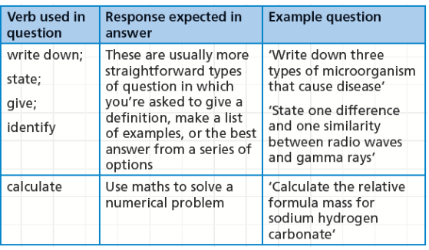
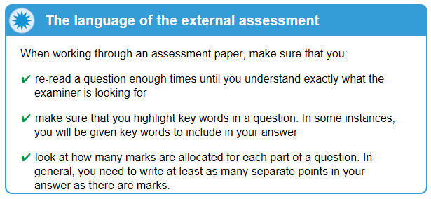
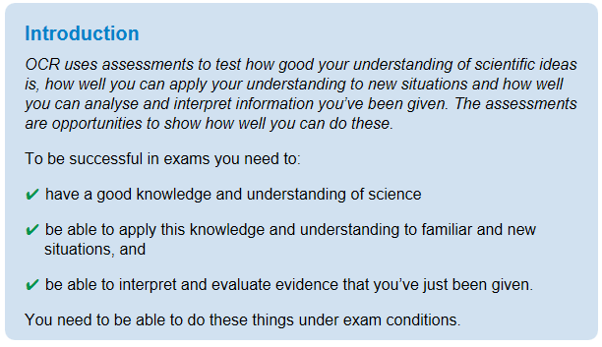
C2a The Structure of the Earth
Grade E Grade C Grade A
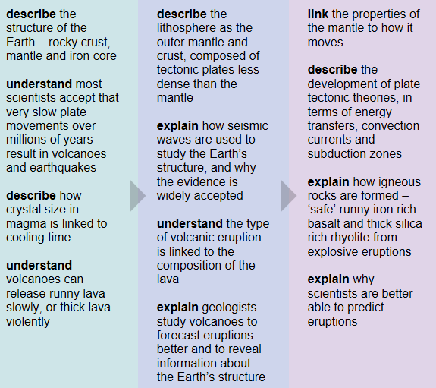
Key Information
The Earth is made of a layered structure, a thin crust, the mantle and an iron core. The two types of tectonic plates are oceanic and continental
Revision Ideas
- Draw a picture labelling the structure of the Earth – Include detailed descriptions
- Find a YouTube clip showing how volcanoes and earthquakes happen
QWC Question (6 marks)
When answering a QWC question remember the following points: Use correct science vocabulary, organise ideas, avoid using “it”, and write in full sentences. You also need to try and keep you answer relevant to the question. A good way to do all this is to write out important key vocabulary and then use them to structure your answer. Underlining them will help you keep track and highlight to the examiner your good use of key terms,
Question – This question is about the structure of the Earth
The Earth is made of a layered structure. Describe the structure of the Earth and use ideas about plate tectonics to explain how the movements cause earthquakes and volcanoes (6marks)
Important words list
Crust
Mantle
Core
Lithosphere
Density
Oceanic Plate
Continental Plate
Tectonic Plates
Earthquake
Volcanoes

C2b Construction Materials
Grade E Grade C Grade A
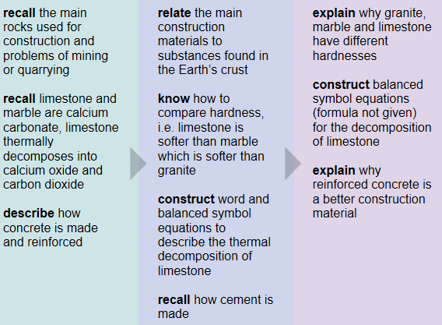
Key Information
When calcium carbonate is heated it breaks down into calcium oxide and carbon dioxide.

Glass, concrete and cement are all made from sand.
Revision Ideas / Task
- Print pictures of the different building materials. Use post it notes to label what each one is made from
- Draw a cartoon showing the impact of mines and quarries on the environment

QWC Question (6 marks)
When answering a QWC question remember the following points: Use correct science vocabulary, organise ideas, avoid using “it”, and write in full sentences. You also need to try and keep you answer relevant to the question. A good way to do all this is to write out important key vocabulary and then use them to structure your answer. Underlining them will help you keep track and highlight to the examiner your good use of key terms,
Question – This question is about construction materials
Many construction materials come from rocks. Describe how 3 different construction materials are made and explain the impact extraction of the raw materials has on the environment (6 marks)
Important words list
Ores
Concrete
Iron / Aluminium
Cement
Sand
Aggregates
Limestone
Reduce
Impact
Environment

C2c Metals and Alloys
Grade E Grade C Grade A
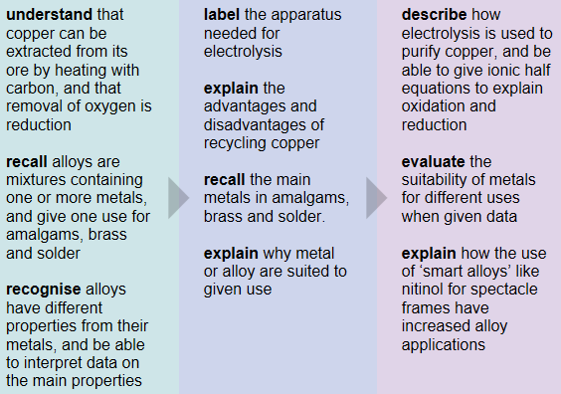
Key Information
Electrolysis uses an electric current to purify copper. Alloys are mixtures of a metal and another element that improves the metals properties to make it more useful
Revision Ideas / Task
- Make revision cards with the following key words. Put their definitions on the back and get family members to test you. (Key words: Reduction, Electrolysis, Electrode, Anode, Cathode, Impurities, Electrolyte, Alloy)
- Make a card game to help you remember the elements that make up different alloys
QWC Question (6 marks)
When answering a QWC question remember the following points: Use correct science vocabulary, organise ideas, avoid using “it”, and write in full sentences. You also need to try and keep you answer relevant to the question. A good way to do all this is to write out important key vocabulary and then use them to structure your answer. Underlining them will help you keep track and highlight to the examiner your good use of key terms,
Question – This question is about the metals and alloy
Explain how copper is extracted form copper ore and then purified using electrolysis (6marks)
Important words list
Heating
Carbon
Reduction
Impure
Electrolysis
Electric Current
Electrolyte
Electrode
Impurities
Cathode
Anode
C2d Making Cars
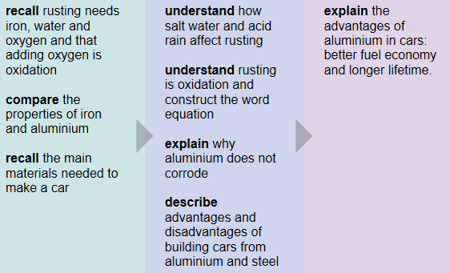
Key Information
Rusting is an example of an oxidation reaction. Rusting needs iron, water and oxygen.
Iron + Oxygen + Water iron oxide

Revision Ideas / Task
- Take a picture of a car and label the different materials used to make it and state why they are good for that purpose.
- Make a notes page on the reasons we recycle. Use a highlighter to colour all the key points
QWC Question (6 marks)
When answering a QWC question remember the following points: Use correct science vocabulary, organise ideas, avoid using “it”, and write in full sentences. You also need to try and keep you answer relevant to the question. A good way to do all this is to write out important key vocabulary and then use them to structure your answer. Underlining them will help you keep track and highlight to the examiner your good use of key terms,
Question – This question is about the materials used to make cars and recycling
Many different materials are used to make cars, Describe why aluminium and steel are chosen to make car bodies and explain how steel corrodes and aluminium doesn’t. (6marks)
Important words list
Density
Malleable
Corrodes
Rusting
Oxidation
Aluminium oxide
Protective Layer
Oxygen
Water
Iron

C2e Manufacturing Chemicals
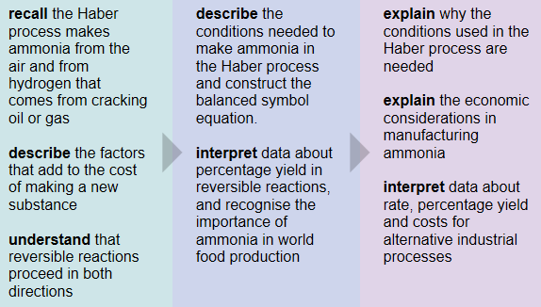
Key Information
Ammonia is a gas made by the Haber process. It is used to make nitric acid and fertilisers.
The reaction is reversible

Revision Ideas / Task
- Record yourself talking about the Haber Process and the factors that affect the cost .Add it to your MP3 playlist
- Draw out the formula with the reversible sign and add the optimum conditions needed

QWC Question (6 marks)
When answering a QWC question remember the following points: Use correct science vocabulary, organise ideas, avoid using “it”, and write in full sentences. You also need to try and keep you answer relevant to the question. A good way to do all this is to write out important key vocabulary and then use them to structure your answer. Underlining them will help you keep track and highlight to the examiner your good use of key terms,
Question – This question is about the Haber Process
Ammonia is an important gas used to make fertilisers. It is made on a large scale in the Haber Process. Describe the Haber Process and the factors that affect the cost of making ammonia. (6marks)
Important words list
High pressure
Catalyst
Nitrogen
Hydrogen
Optimum Conditions
Unreacted Gases
Costs
Temperature
Workforce
Equipment

C2f Acids and Bases
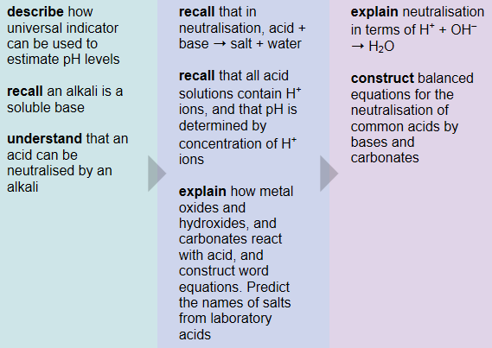
Key Information
A soluble base is called an alkali. When you neutralise an acid with a base the reaction produces a salt + water.

Revision Ideas / Task
- Practice naming the salts made when reacting different acids and bases. Use your what salt cards to help
- Draw out and colour the pH scale

QWC Question (6 marks)
When answering a QWC question remember the following points: Use correct science vocabulary, organise ideas, avoid using “it”, and write in full sentences. You also need to try and keep you answer relevant to the question. A good way to do all this is to write out important key vocabulary and then use them to structure your answer. Underlining them will help you keep track and highlight to the examiner your good use of key terms,
Question – This question is about the neutralisation reactions
When an acid and a base are added to each other in the correct amounts they can cancel each other out. This is called a neutralisation reaction. Write about neutralisation reactions; include in your answer ideas about ions. (6marks)
Important words list
Neutral
Acid
Alkali
pH
Salt
Water
Hydroxide Ions
Hydrogen Ions
Solution
C2g Fertilisers and Crop Yield
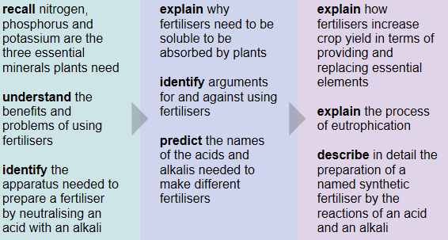
Key Information
Fertilisers make crops grow faster and quicker and increase crop yield. Eutrophication is a problem with using fertilisers
The three main elements found in fertilisers are Nitrogen Phosphorus and Potassium

Revision Ideas / Task
- Draw out and label the equipment needed to make a fertiliser by neutralisation
- Come up with a Pneumonic to remind you of the 3 essential elements found in fertilisers. NPK

QWC Question (6 marks)
When answering a QWC question remember the following points: Use correct science vocabulary, organise ideas, avoid using “it”, and write in full sentences. You also need to try and keep you answer relevant to the question. A good way to do all this is to write out important key vocabulary and then use them to structure your answer. Underlining them will help you keep track and highlight to the examiner your good use of key terms,
Question – This question is about Fertilisers
Farmers use fertilisers on their crops. Describe what a fertiliser must be and explain the advantages and disadvantages of using them on farmland. (6marks)
Important words list
Nitrogen
Phosphorus
Potassium
Soluble
Yield
Faster / Bigger
Eutrophication
Algae Bloom
Roots
Death of Animals

C2h Chemicals from the Sea
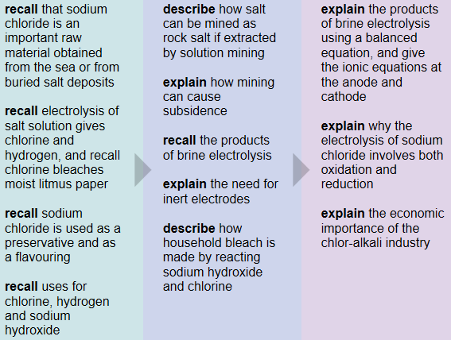
Key Information
Sodium chloride can be removed from the sea or mined from salt deposits. When sodium chloride solution is electrolysed it makes sodium hydroxide, hydrogen and chlorine.
Revision Ideas / Task
- Draw and label the process of sodium chloride electrolysis.
- Make a card sort on the products of electrolysis of sodium chloride and their uses.
QWC Question (6 marks)
When answering a QWC question remember the following points: Use correct science vocabulary, organise ideas, avoid using “it”, and write in full sentences. You also need to try and keep you answer relevant to the question. A good way to do all this is to write out important key vocabulary and then use them to structure your answer. Underlining them will help you keep track and highlight to the examiner your good use of key terms,
Question – This question is about the electrolysis of sodium chloride
Sodium chloride is an important raw material in the chemical industry. Explain how sodium chloride can be separated into useful products using electrolysis and describe the uses of these products. (6marks)
Important words list
Solution
Anode
Cathode
Chlorine
Sterilise
Sodium Hydroxide
Hydrogen
Bleach
Margarine
Litmus Paper

