What mass of carbon would you need to burn in excess oxygen to make to make 84g of carbon dioxide ? C + O2 🡪 CO2

Mr C = 12, Mr CO2 = 44 therefore 12 g of C makes 44 g of CO2. Divide by 44 to calculate how much carbon will make 1 g of CO2. 0.27 g of C will make 1 g of CO2. Multiply by 84 to work out how much C is needed to make 84 g of CO2. **Answer 22.9 g of C is needed.**

Why do industries want a high atom economy?

To reduce the formation of unwanted products. This makes the process more sustainable as it is more efficient and it also makes better use of the reactants, conserving raw materials.

Explain conservation of mass in terms of particles

The total number of atoms you start with (the reactants) is equal to the total of number of atoms in the products. There the mass of the reactants is the same as the mass of the products

How is product mass affected by reactants

The greater the mass of the reactants the greater the mass of products obtained.

The amount of product obtained is directly proportional to the amount of limiting reactant used

What happens if surface area of reactants is increased?

Rate of reaction increases. Reducing the size of particles increases the rate of a reaction because it increases the surface area available for collisions to take place. This increases the collisions each second, and so the rate of reaction increases.

What are allotropes?

Different structures of the same element e.g. diamond, graphite and fullerenes are allotropes of carbon.

Ozone is an allotrope of oxygen

How does the limiting reactant affect a reaction?

The limiting reactant is the reactant not in excess. It is the reactant that is used up in the reaction. When all of it has reacted the reaction will finish. The amount of product obtained is directly proportional to the amount of limiting reactant used.

Describe and explain how and why the rate of reaction changes during a reaction? Starts at 0 as no product is made because reactants have not reacted.

Steepest part of graph showing the fastest rate of reaction. This is because most the reaction mixture is reactants, so there a lot of collisions.

The rate of reaction slows down, this can be seen on the graph as the gradient/slope of the graph decreases. The reaction mixture now contains a mixture of reactants and products. So there are less reactant particles colliding. The line of the graph levels off and stops changing. This shows that reaction has stopped. All of the reactant particles have reacted to form products. (one of the reactants may have been in excess and this will be in the reaction mixture).

What would a graph of rate during a reaction look like?

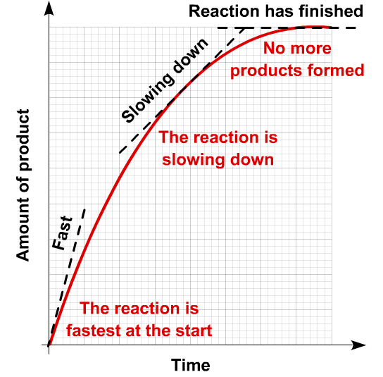

How does the collision theory explain rates?

What happens when temp is increased in a reaction?

Rate increases. Particles move faster as temperature increases. The reacting particles have more kinetic energy and so the number of collisions increases. The collisions are also more energetic and therefore successful.

What happens when conc is increased in a reaction?

The rate of reaction increases. There are more particles in the same volume; this means that the particles are closer together. There are more collisions, and so the number of collisions per second increases (the collision frequency increases).

What is a catalyst?

A substance that speeds up the rate of reaction but is not used up during the reaction (it remains chemically unchanged and does not appear in the final product). It makes the collisions that take place more successful.

How do you find the rate of reaction from the graph below?

The gradient of the slope.

Rate of reaction =

amount of reactant used

Time

Or Rate of reaction =

amount of product formed

Time

How do you find relative molecular mass?

Add up all of the atomic masses found in the molecule

What are the energy changes in bond making and bond breaking?

Bond breaking – endothermic (energy required)

Bond forming – exothermic (releases energy)

What are exothermic and endothermic reactions?

**Exothermic** – gives out energy to the surroundings **usually** in the form of heat and shown by a rise in temperature

**Endothermic** – takes in energy from the surroundings **usually** in the form of heat which is shown by a fall in temperature

Give the equation for finding the energy transferred when a fuel burns

Energy transferred (J) =

Mass of water (g) x specific heat capacity of water x temperature change

Find RMM of NH4Cl

14 + (1 x 4) + 35.5 = 53.5

How do you find atom economy?

Atom economy =

Mr of desired product x100

Sum of Mr of all products

Why do industries want a high percentage yield?

To reduce waste and maximise profits.

Costs money to dispose of waste.

What factors affect the cost of making a drug?

Research and development – find a suitable compound and then testing it

Trialing – needs testing to prove it meets legal requirements

Manufacture – often batch production

What are the properties of diamond and how do they relate to the structure?

Carbon in diamond forms four covalent bonds, there a lot of these bonds. It is a giant covalent structure. Because there a lot of these bonds and they are strong it has a high melting points. It doesn’t dissolve in water. It does not conduct electricity because there are not free electrons (all outer shell electrons are used in bonding) or ions to carry the charge.

Why does graphite conduct electricity?

Each carbon atom only forms three covalent bonds in graphite. These means there are free (delocalised) electrons that can move and carry charge. This means that graphite can conduct electricity.

What are the uses of Buckminster fullerene and why?

Used to cage other molecules and then used for the slow release of drugs inside the body.

Catalysts due to large surface area.

What are the criteria for a batch process?

Small scale production, flexible (can use equipment to make different products), does not run continuously, labour intensive (setting up equipment and cleaning it regularly), large workforce, low output.

How do you find percentage yield?

Percentage yield = actual yield (grams) x 100

Predicted (grams)

**C3**

**Chemical Economics**

Add notes and diagrams to make it useful