How do you work out the number of electrons in the outside shell?
Proton:
Neutron:
Electron:

Isotope:

Group 7
Forms _________________ charged ions. By _____________ an electron. This is __________________. Group 7 gets _______ reactive as you go down the group.
Description of Halogens (F,Cl, Br):

Symbol equation of Group 7 & Group 1:

Describe the displacement reactions:

Group 1
Forms _________________ charged ions. By _____________ an electron. This is __________________. Group 1 gets _______ reactive as you go down the group because _________ electron shells. The melting points __________ as you go down the group due to ___________ metallic bonds as the number of electron shells _____________.
Giant ionic lattice:
Symbol equation of Group 1 & water
Method for Flame Tests

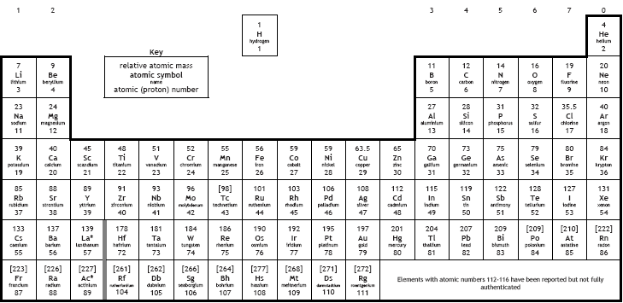

Transition Metal
Describe colours of transition metals:
Describe uses of transition metals:
Symbol equation of thermal decomposition of transition metals:
Describe how to test for transition metal ions:

Ionic Bonding | Covalent Bonding | Metallic Bonding
Definition  Forms between which sorts of atoms?  Draw a diagram of the bonding: NaCl | Definition  Forms between which sorts of atoms?  Draw a diagram of the bonding: Cl2 Molecule | Definition  Forms between which sorts of atoms?  Draw a diagram of the bonding
Purifying Water: Testing with Barium Salts
Scientists & Periodic Table
- Dobereiner

- Newlands

- Mendeleev
Scientists & Structure of the Atom:
- Dalton
- JJ Thomson
- Rutherford
- Bohr

