GCSE
“We are what we repeatedly do. Excellence, therefore, is not an act but a habit”
Core Gateway Science B
P1: Energy from the Home

Unit |  | Page | Completed By
1a | Heating Houses | 80
1b | Keeping Homes Warm | 83
1c | A spectrum of waves | 86
1d | Light and Lasers | 88
1e | Cooking and Communicating using Waves | 90
1f | Data Transmission | 92
1g | Wireless Signals | 93
1h | Stable Earth | 94
Use the activities and past exam questions in this booklet to plan and support your revision ready for the B1C1P1 science exam.
REVISION WEBSITE – The follow website is available for you to use to support you revision and help you answer the exam questions in this revision guide
http://www.bbc.co.uk/schools/gcsebitesize/science/ocr_gateway/
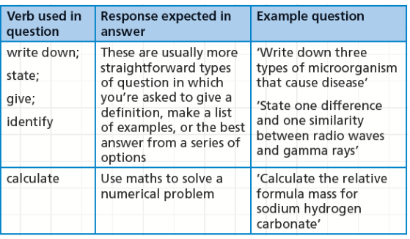
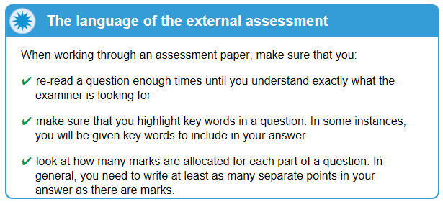
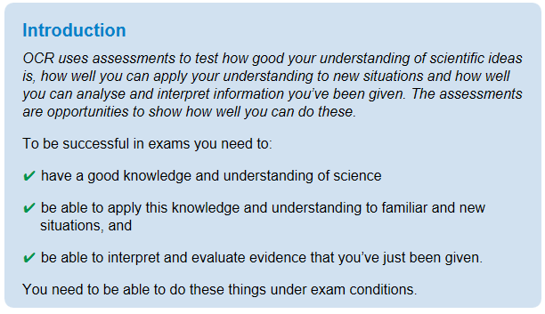
P1a: Heating Houses
Grade E Grade C Grade A
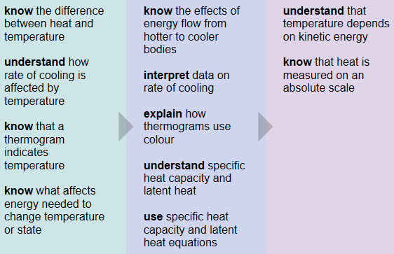
Key Information
Heat energy is needed to increase the temperature of an object. The amount of energy needed depends on the mass of the object, the type of material it is made from and the temperature increase.

Heat energy is also absorbed when substances melt or boil, but the temperature does not alter during a change of state. The amount of energy needed to melt or boil something depends upon the mass of the object and the type of material it is made from.
Revision Ideas
- Draw a mind map for the P1 unit. Add pictures and colour code key words and information
- Write some practice exam questions for other students to try, make sure you write a mark scheme.
QWC Question (6 marks)
When answering a QWC question remember the following points: Use correct science vocabulary, organise ideas, avoid using “it”, and write in full sentences. You also need to try and keep you answer relevant to the question. A good way to do all this is to write out important key vocabulary and then use them to structure your answer. Underlining them will help you keep track and highlight to the examiner your good use of key terms,
Question – This question is heating
A liquid in a beaker is heated to a certain temperature. State what the amount of energy needed to heat the water depends on, and describe what happens to the temperature of the water as it changes state. (6marks)
Important words list
Temperature
Heat
Changes of state
Melting
Boiling
Gas, Solid, Liquid
Latent heat
Mass
Energy

P1b: Keeping Homes Warm
Grade E Grade C Grade A
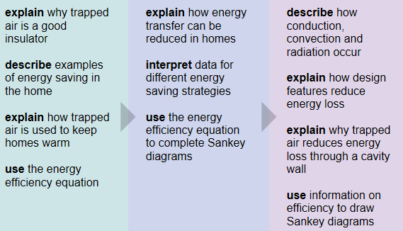
Key Information
Heat energy can be lost from homes in many different places but there are ways of reducing these losses.

Heat can be transferred from place to place by conduction, convection and radiation. Dark matt surfaces are better at absorbing heat energy than light shiny surfaces

Revision Ideas
- Draw a diagram of a house. Label all the places where heat is being lost and how heat loss is minimised.
- Write out the formula for working out energy efficiency. Practice using the equation.

QWC Question (6 marks)
When answering a QWC question remember the following points: Use correct science vocabulary, organise ideas, avoid using “it”, and write in full sentences. You also need to try and keep you answer relevant to the question. A good way to do all this is to write out important key vocabulary and then use them to structure your answer. Underlining them will help you keep track and highlight to the examiner your good use of key terms,
Question – This question is about Energy transfer
It is very cold in the Arctic. Explorers keep warm because they have fur coats. Describe the different ways an explorer can lose heat and explain how they could reduce heat loss. (6marks)
Important words list
Conduction
Convection
Radiation
Absorbs
Radiates
Particles
Insulator
Conductor
Vacuum
Vibrations
P1c: A Spectrum of Waves
Grade E Grade C Grade A
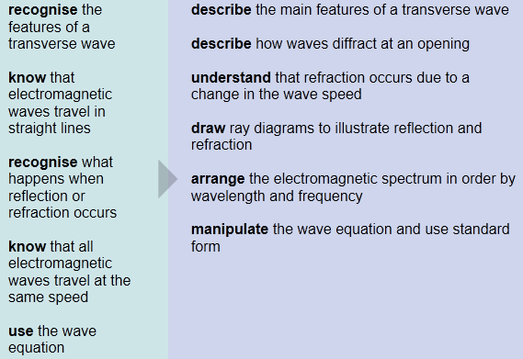
Key Information
White light can be split up into many colours by using a prism. This visible light is just part of the whole spectrum of electromagnetic radiation. Not all types of electromagnetic radiation are visible. Each type has a different wavelength and a different use in everyday life. Electromagnetic radiation can be used for wireless communications.
Revision Ideas
- Draw a diagram of a transverse wave and label the following; crest, trough, amplitude, wavelength
- Create a poster of the electromagnetic spectrum. Add pictures for all the different uses of the different wavelengths.
QWC Question (6 marks)
When answering a QWC question remember the following points: Use correct science vocabulary, organise ideas, avoid using “it”, and write in full sentences. You also need to try and keep you answer relevant to the question. A good way to do all this is to write out important key vocabulary and then use them to structure your answer. Underlining them will help you keep track and highlight to the examiner your good use of key terms,
Question – This question is fighting disease.
When a ray of light hits a mirror it is reflected. Draw a diagram showing this reflection, labelling the key parts and then use the diagram to explain how a periscope uses this reflection to view objects. (6marks)
Important words list
Reflection
Plane Mirror
Angle
Incidence
Refection
Equal
Normal Line
Ray of light
Periscope
P1d: Light and Lasers
Grade E Grade C Grade A
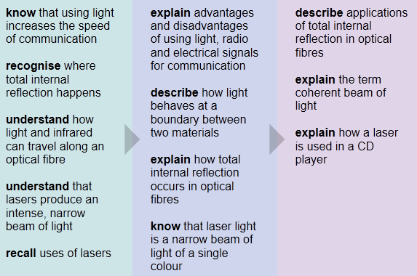
Key Information
Digital signals are a series of pulses with two states - on or off. Light can be used for digital communications, such as in Morse code and CD players. Optical fibres can carry information coded in light waves or infrared waves. Lasers produce intense narrow beams of light.

Revision Ideas
- Write a message using a digital signal such as Morse code.
- Produce a revision card on Total Internal Reflection. Your revision aid should include a diagram.

QWC Question (6 marks)
When answering a QWC question remember the following points: Use correct science vocabulary, organise ideas, avoid using “it”, and write in full sentences. You also need to try and keep you answer relevant to the question. A good way to do all this is to write out important key vocabulary and then use them to structure your answer. Underlining them will help you keep track and highlight to the examiner your good use of key terms,
Question – This question is about sending signals.
Signals can be sent by light, electrical, radio waves or microwaves. Discuss the advantages and disadvantages of each type of signal (6marks)
Important words list
Instantaneous
Secure
Equipment
Wires
Amplified
Large Distances
Space
Atmosphere
C1e: Cooking and Communicating Using Waves
Grade E Grade C Grade A
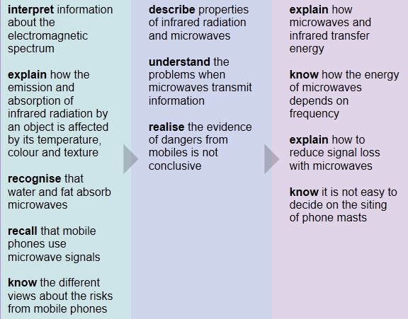
Key Information
Infrared radiation and microwaves can be used to cook food. Microwaves are also used to transmit information, such as mobile phone networks.
Revision Ideas
- Make some true false statements cards. Practice sorting them into true/false piles. Time yourself and see if you can beat it the next day.
- Write a script for a “TV drama” where the characters are concerned about the dangers from a new mobile phone mast being situated near their homes
QWC Question (6 marks)
When answering a QWC question remember the following points: Use correct science vocabulary, organise ideas, avoid using “it”, and write in full sentences. You also need to try and keep you answer relevant to the question. A good way to do all this is to write out important key vocabulary and then use them to structure your answer. Underlining them will help you keep track and highlight to the examiner your good use of key terms,
Question – This question is about infrared and microwave cookery.
Infrared radiation and microwaves are part of the electromagnetic spectrum. Both can be used to cook food. Describe how food is cooked using microwaves and infrared, making sure you identify the differences between the two methods. (6marks)
Important words list
Absorbed by water
Molecules
Penetration
Surface
Reflected
Kinetic Energy
Conduction / Convection
Energy
Wavelength
C1f: Data Transmission
Grade E Grade C Grade A
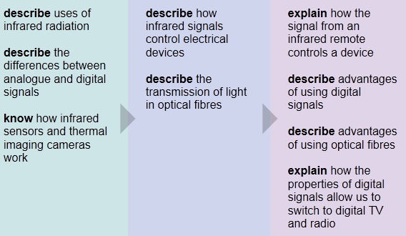
Key Information
Information can be transmitted using analogue or digital signals

Revision Ideas
- Produce a revision card on the uses of infrared radiation
- Make a card sort on the differences between digital and analogue signals. Practices sorting the statements into two piles.

QWC Question (6 marks)
When answering a QWC question remember the following points: Use correct science vocabulary, organise ideas, avoid using “it”, and write in full sentences. You also need to try and keep you answer relevant to the question. A good way to do all this is to write out important key vocabulary and then use them to structure your answer. Underlining them will help you keep track and highlight to the examiner your good use of key terms,
Question – This question is about Optical Fibres
Optical fibres are used to transmit data. Draw a diagram to show how optical fibres work and state the advantages of using optical fibres instead of copper wires for data transmission. (6marks)
Important words list
Reflection
Speed of light
Long distances
Coating
Total Internal Reflection
Angle of incidence
Angle of reflection
Energy Loss
C1g: Wireless Signals
Grade E Grade C Grade A
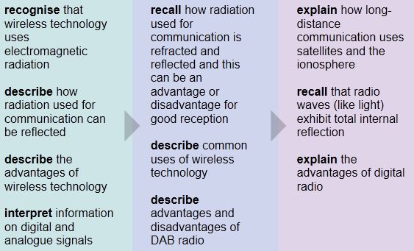
Key Information
Wireless communication is convenient. It is used for radio programmes, mobile phones and computer networks. DAB broadcasts have advantages and disadvantages compared to traditional analogue broadcasts.

Revision Ideas
- Make a poster showing how the TV signal to a house can be reflected causing a problem called “ghosting”
- Write an exam question with mark scheme about the refraction of electromagnetic waves

QWC Question (6 marks)
When answering a QWC question remember the following points: Use correct science vocabulary, organise ideas, avoid using “it”, and write in full sentences. You also need to try and keep you answer relevant to the question. A good way to do all this is to write out important key vocabulary and then use them to structure your answer. Underlining them will help you keep track and highlight to the examiner your good use of key terms,
Question – This question is about radio interference.
Shaun is listens to the same radio station every day. Some days he can hear the faint sound of a different station in the background. Explain to Shaun why he can hear the other station and describe the advantages and disadvantages of buying a digital radio (6marks)
Important words list
Frequency
Interference
Distance
Weather
Digital
More stations
Poor coverage
Audio Quality

C1h: Stable Earth
Grade E Grade C Grade A
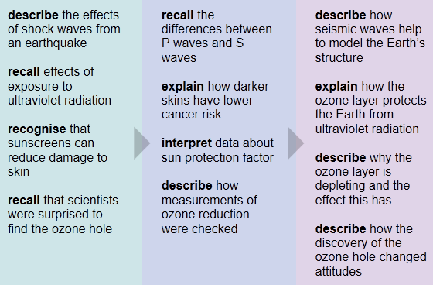
Key Information
Earthquakes produce shock waves that cause damage. There are two types of seismic wave, P-waves and S-waves. Seismometers can detect these waves and provide evidence of the Earth’s structure.

The ozone layer reduces the amount of ultraviolet light from the Sun that reaches the Earth’s surface. Exposure to ultraviolet radiation can lead to sunburn and skin cancer, but sunscreens can reduce this damage.
Revision Ideas
- Draw a picture showing how a seismometer measures the strength of an earthquake. Cut it up and make it into a jigsaw puzzle.
- Write an information card that can be passed to tourists as they go on holiday informing them about the harmful effects of UV radiation and how to avoid them.
QWC Question (6 marks)
When answering a QWC question remember the following points: Use correct science vocabulary, organise ideas, avoid using “it”, and write in full sentences. You also need to try and keep you answer relevant to the question. A good way to do all this is to write out important key vocabulary and then use them to structure your answer. Underlining them will help you keep track and highlight to the examiner your good use of key terms,
Question – This question is variation
Sandra is going on holiday and wants to get a suntan. A tan is caused by the action of ultraviolet radiation. Describe the dangers of sunbathing and explain to Sandra how she can use the sun index to reduce the risks of sunbathing. (6marks)
Important words list
Melanin
Pigment
Skin Cancer
Ultra Violet
Strength of the Sun
Sunscreen
SPF Number
Amount of time in the sun

