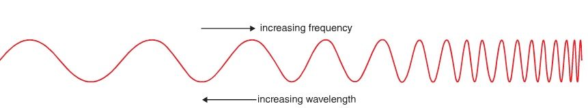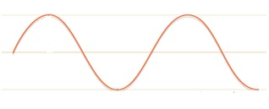

**How did people used to send messages using lamps?**

**Name 4 uses of lasers:**

**Label the EM spectrum:**

**List 3 properties of Electromagnetic Waves:**

**Label the amplitude and wavelength:**

**What is this diagram called?**

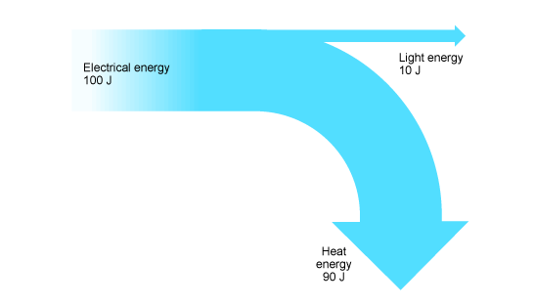

**How is energy efficiency calculated? How is payback time calculated?**

**List 4 ways people can insulate their homes:**

**What is Conduction?**

**What is Convection?**

**What is Radiation?**

**Define Specific Heat Capacity:**

**SHC Calculation:**

**Define Specific Latent Heat:**

**SLH Calculation:**

**What is the difference between temperature and heat?**

**What is a thermogram?**