**P3 Summary Foundation**

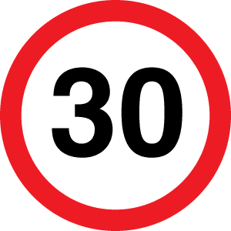

**Graphs**Distance Time Graphs – flat line means the person is stopped, the gradient indicates the speed

Speed Time Graphs – flat line means the speed is constant and the gradient indicates the acceleration.

**Speed**  
**Speed = Distance  
 time**  
Speed limits depend on the type of road – e.g. slower speed limits in urban areas near schools.

Speed cameras take 2 photos 0.5s apart and measure distance by the white lines on the road. They can then calculate speed of the car.

**Velocity**The speed of a moving object in a certain direction.

Relative Velocity – If 2 trains are moving past each other in opposite directions at 30m/s, to people on train 2 it will seem like train 1 is moving at 60m/s. This is the velocity of train 1 relative to the velocity of train 2.

**Forces**  
**Force = mass x acceleration**

If the forces are balanced, then the object is stationary or moving at a   
constant speed.

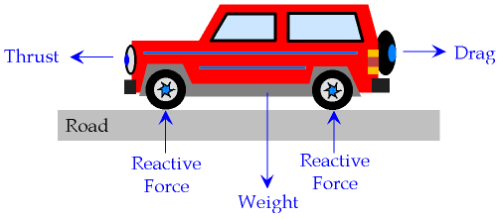

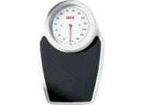

**Road Safety**Stopping Distance = Thinking Distance + Stopping Distance  
Thinking Distance is affected by drugs, alcohol, tiredness, lack of concentration and speed.  
Braking Distance is affected by road   
conditions, worn tyres, worn brakes,   
mass of car and speed.

**Work and Weight**Work is done when a force moves.   
**Work Done = Force x Distance Moved**

Weight is the force of attraction on a mass due to gravity.   
Weight = Mass x 10 (gravitational field strength)



**Power and Fuel  
Power = Work Done  
 time taken**  
Powerful cars (with bigger engines) have a higher fuel consumption, so are expensive to run. Fuel products pollute the environment.

**Fuels**Petrol and diesel are **fossil fuels**. These cause pollution such as global warming.  
Some renewable energy sources, such as **biofuels** are being developed.  
**Solar** energy is being considered for cars.  
**Electric** cars are becoming more common – often using batteries, which have to be charged.

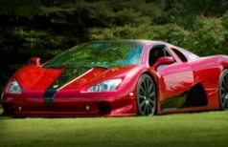

**Cars**Cars that are streamlined reduce friction, so they can improve their fuel consumption.   
You can do this by:   
Shaping car roof boxes  
Creating cars in a wedge  
Angling lorry deflectors

**Kinetic Energy**All moving objects have kinetic energy.  
**KE is calculated by = ½ mv2** m = mass, v = speed. KE is measured in joules (J).





**Safety Features to Prevent Crashes (Primary Safety Features)**1. Anti-lock brakes  
2. Traction control (prevents wheel spin)  
3. Electric windows (limits distraction)  
4. Controls on the steering wheel (limits distraction)

**Safety Features to Protect People (Secondary Safety Features)**1. Crumple zones that absorb energy and increase stopping time  
2. Seatbelts that stretch to slow a person down  
3. Air bags that inflate to absorb a person’s KE  
These features must be crash tested before cars are sold.

**Momentum**Moving cars have momentum.  
**Momentum = mass x velocity**  
In accidents cars stop suddenly, so momentum becomes 0. This rapid change leads to a large force in a crash, risking injuries. You must reduce forces to reduce injuries.

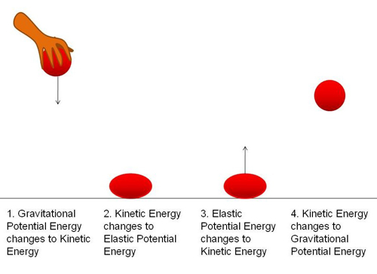[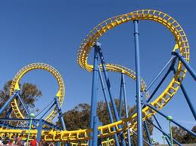](http://www.google.co.uk/imgres?q=rollercoaster&hl=en&biw=1024&bih=571&tbm=isch&tbnid=_iYGmm-H37dJjM:&imgrefurl=http://cepolina.com/roller_coaster_curve_yellow_overall.html&docid=q88a8hlyadXAmM&imgurl=http://www.cepolina.com/photo/technology/funfair/roller_coaster/2/roller_coaster_curve_yellow_overall.jpg&w=640&h=480&ei=AmTrT4-wHITQ-gal4cDnBQ&zoom=1&iact=hc&vpx=278&vpy=242&dur=1890&hovh=194&hovw=259&tx=134&ty=129&sig=116666784730613600908&page=2&tbnh=119&tbnw=159&start=9&ndsp=20&ved=1t:429,r:6,s:9,i:122)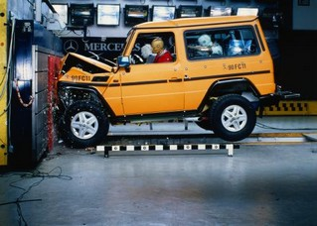

**Gravitational Potential Energy (GPE)**Any object held above the ground has GPE. This varies with the **mass** of the object and the **height** it is held at.

A car on a rollercoaster at the top of a hill has lots of GPE. This converts to kinetic energy as it moves down the hill. Some energy is wasted as sound and heat.

**GPE = mgh**m = mass (kg)  
g = gravitational field strength (10N/kg)  
h = height (m)

**Falling Objects**Objects fall because of **gravity**. Objects with a bigger surface area have more drag (air resistance) so fall more slowly.  
When air resistance equals weight, the forces are balanced and the falling object reaches **terminal speed**. This is a constant speed.